With the elements of PIETY,
We aspire to SANTITY.

It is through STUDY that we are FORMED.

Through our ACTIONS EVANGELIZATION will be enabled.

Perseverance in the three times:
Piety, Study, Action

Kept by the Group Meeting,
Ultreya and School of Leaders

Prayer to the Holy Spirit

Come Holy Spirit, fill the hearts of your faithful, kindle in them the flame of your love, send your spirit and everything will be created again and renew the peace of the earth. Oh God who has
enlightened the hearts of your children with the light of the Holy Spirit, make us docile to your spirit to always taste the good and enjoy your comfort through Jesus Christ our Lord. Amen.

Leader's Prayer
Grant, Lord, that we understand the need for our work to have more depth than surface. Convince us that visible programs are not success.
My God, multiply the self-sacrificing souls who know how to sacrifice everything to your cause: their time, their faculties, their health, and even their lives, if necessary; instill them with audacity in the initiatives, success in the choice of means and the tenacity that, despite the failures, ensures triumph.
Remove from them all petty rivalries, sensitivities, vanities, roughness, and everything that distracts from the idea of God, everything that divides and discourages.
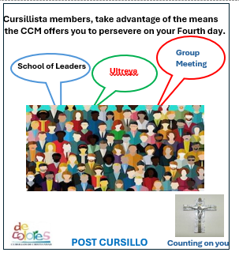
Aim to preserve a high sense of the supernatural and a very effusive mutual charity. Let each one to seek with preference the most thankless tasks and rejoice in the good done by others.
FRIENDSHIP AND THE CURSILLOS OF CHRISTIANITY

In all these souls united for a common purpose, may there be only one soul: yours Jesus! And may this soul allow us to recognize in all faces your inviting goodness, in all words your touching accent, and in the whole of his work something that is superior to the world, something that proclaims your action.

The Cursillo Movement of Christianity

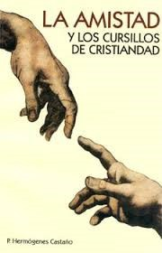
About the Cursillo Movement
The method of the apostolate of Cursillos is friendship and it is
for those distanced from God.

Location of the ultreyas in the Diocese of Venice

Holly Cross, Palmetto,
Sacred Heart, Bradenton
St. Michael, Wauchula
Santiago Mission, Lake Placid Jesus the Worker, Fort Myers
Saint Andrew, Cape Coral
Our Lady of Guadalupe, Immokalee
San Rafael, Lehigh Acres
St. Paul, Arcadia (School of Leaders)
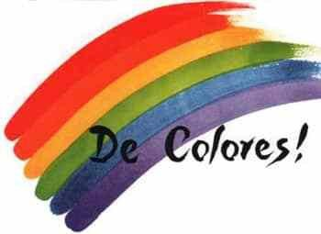

Juan Hervas and Benet
Msgr. Juan Hervas y Benet who as Bishop of Mallorca, together with layman Eduardo Bonnin and the priest
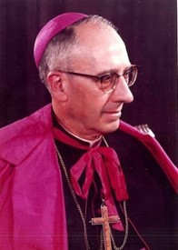
Fr. Sebastián Gaya are considered as the initiators of the Cursillos de Cristiandad Movement. Born in Puzol, Valencia, on November 30,1905.
Vicar of the Parish of Jesús Pobre, in Denia, and parish priest of Ayódar. In 1931 he was appointed director of the Colonia San Vicente Ferrer Reformatory of Godella, and a year later as Regent Priest of Vinalesa. Always concerned about working with the laymen, will attend the courses of the House of the Counselor of Catholic Action, of Madrid.

Between 1936 and 1939 he studied at the Catholic University of Fribourg, Switzerland, obtaining his doctorate in Canon Law and Civil Law. In 1939 he was appointed Director of the Colegio Mayor de San Juan de Ribera de Buijasot.

Eduardo Bonnín Aguiló
He was born in Palma de Mallorca on May 4, 1917, in the family residence house, where the bar Nice is located today; within a Catholic family dedicated to trade and export.
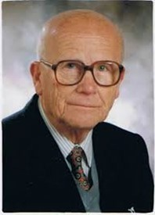
In 1943 Eduardo participates in the second "Cursillos for Pilgrim Leaders" where he gets convinced that what is shared is very dense and boring. He
relates what he experienced in the Pilgrim’s Cursillo with his deepest personal concerns and with his catalytic experience of dechristianized environments. He concluded that something both similar and different from that Pilgrim Leaders’ Cursillo had to take place.

From this concern a text emerges - the scheme "Study of the Environment"-that Eduardo elaborated this same year of 1943, and that he exhibited in public for the first time in the Diocesan Seminary of Mallorca.

In this climate and projecting the reality of his scheme of Study of the Environment, Eduardo thought and elaborated - from the experience of the Course of Pilgrim Leaders - a whole method that would serve to ferment in Christianity the “distant” people and environments and to revitalize in depth those closest to it.
Perhaps the turning point in his activity was marked by the intervention that Eduardo had at the invitation from Gayà, in 1944. In the "School of Propagandists" that the latter was directing and in which Eduardo exposed the scheme that he had prepared as the final theme of "his" method, which would become part of the roll of "Cursillista beyond the Cursillo.”
The first Cursillo was held according to Eduardo's schemes in a “villa” in Cala Figuera de Santany in Mallorca, between August 20 and 23, 1944.
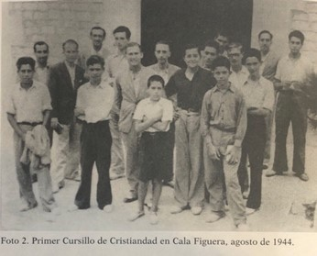
Eduardo Bonnin, founder of the Cursillos of Christianity.

Diocesan Spiritual Director:
Fr. Claudio Stewart
Diocesan Coordinator:
Mr. Gabino Garcia
gabino.garcia9@gmail.com

