John XXIII Parish Retreat
Movement

About the Movement
The John XXIII Parish Retreat Movement is a private international association of lay faithful. It was born to be a movement of evangelization and conversion, to work mainly for those far from the Church and marginalized from society, without distinction.
For the fulfillment of this mission, the John XXIII Movement has a presence, a spirituality of authentic evangelizing service, framed in Love, Surrender and Sacrifice and expressed in a choice of life:
"With Christ all, without Christ nothing."
To achieve its objectives, the John XXIII Movement, in fidelity to the Gospel, Tradition and the Magisterium of the Church, uses its own means and resources approved by the International Board.
Some of the means and resources are the Evangelization and Conversion Retreats of three (3) days, the Follow-up Retreats of one (1) day and the Day of Prayer and Worship at the International level on the weekend closest to October 11, feast of St. John XXIII, main patron of the Movement.
For information regarding Retreats or Movement activities in Venice, Florida, please call (941) 301-6893 or email to: Estelag2000@hotmail.com

Diocese of Venice, FL

Diocese of Venice, FL

John XXIII Parish Retreat
Movement

Come Holy Spirit
Come, Holy Spirit,
Fill the hearts of your faithful
and turn the fire of your love on them.
Send your Spirit and all will be created,
and will renew the face of the earth.
John XXIII Movement
RETREAT HOUSE

Campo San José
170 S Sun "N" Lakes Blvd.
Lake Placid FL. 33852

juanxxiiiestadosunidos.com

Oh, God
you have instructed the hearts of your faithful
with the light of the Holy Spirit;
Grant that we may feel righteously
with the same Spirit,
and let us always enjoy your divine consolation.
John XXIII Movement
Venice, Florida
Estela Gomez
(941) 301- 6893
Diocesan President

Through Jesus Christ our Lord.

Amen.
Saint John XXIII
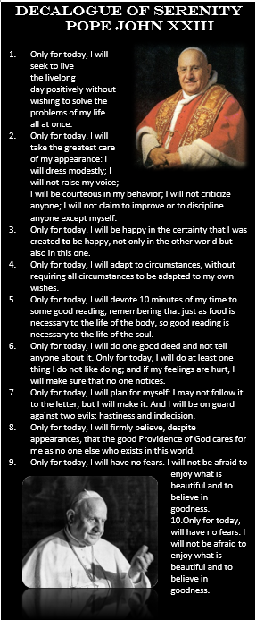
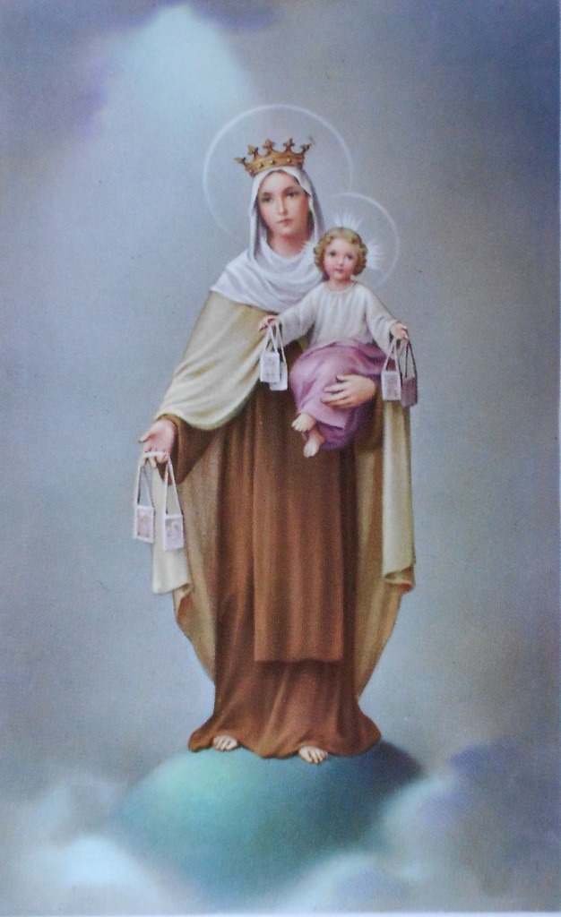
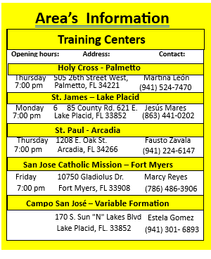
If you have already done the John XXIII Retreat, look for an area near you…….

Parish or Inter-Parish Areas
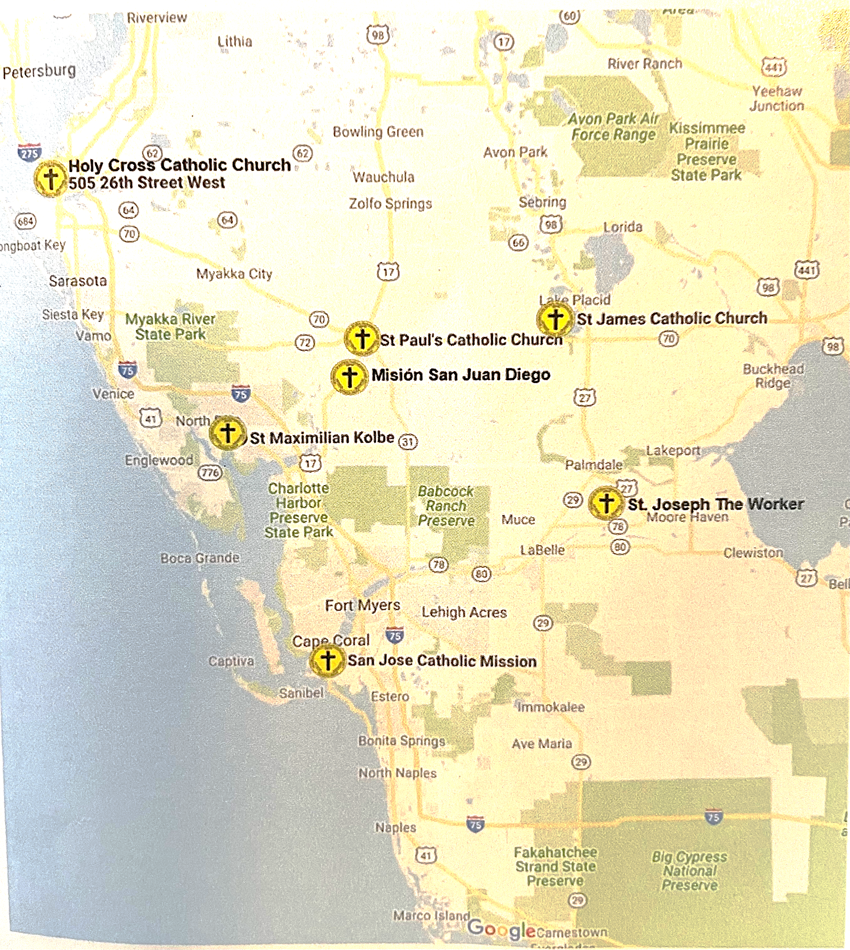
Jesus Mares

Pope Francis
Expected Fruits of a John XXIII Retreatant
Obedience Firmness
Loyalty Humility
Generosity Patience

“Christ is counting on you.”

Christ Counts on You"

Expected Fruits of a

