Prayer Groups

East Deanery
Our Lady Queen of Heaven
La Belle
Holy Martyrs - La Belle St. Michael - Wauchula St. Paul - Arcadia
St. Paul Youth Group
Arcadia
St. Margaret - Clewiston Santiago Apostol Mission
Lake Placid
St. Catherine - Sebring
Our Lady of Grace - Avon Park

North Deanery

St. Jude - Sarasota
Sacred Heart - Bradenton Holy Cross - Palmetto

Central Deanery

St. Andrew - Cape Coral Jesus the Worker - Ft Myers San Jose Mission - Fort Myers.
St. Raphael - Lehigh Acres
St. Leo - Bonita Springs
Our Lady of Light - Estero
St. John XXIII - Ft Myers

South Deanery

St. Elizabeth - Naples
St. Peter - Naples
Our Lady of Guadalupe
Immokalee

Diocesan Council

Moderator
Rev. Claudio Stewart Spiritual Advisors Rev. Wilner Durosier Rev. Elbano Muñoz

Coordinator
Mr. Maynor Ramirez Sub-Coordinator
Mr. Margarito Ronquillo
Secretary Claudia Francisco Treasurer
Mr. Rodrigo Martinez

Youth Secretariat
Mr. Adrian Gonzalez
Ministry of Intercession
Mr. Juan Mondragon
Ministry of Evangelization Mrs. Azucena Calzada
Ministry of Formation
Mr. Juan Mateo Mr. Rosalio Arias
Events Ministry
Mrs. Juana Linares
Mrs. Sandra León
Mr. Juanito Lopez
Email: rcchispana_venice@yahoo.com
Facebook Page:
RCCH Diocese of Venice

Hispanic Catholic Charismatic Renewal
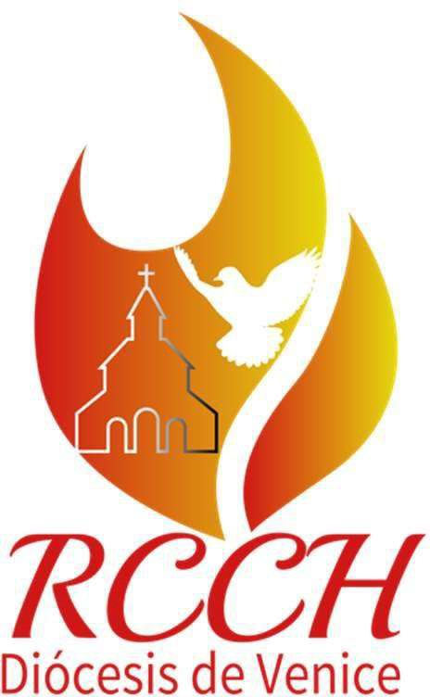
DIOCESE OF VENICE
The Catholic Charismatic Renewal invites us to have a profound experience with the Holy Spirit that opens us up to change in our lives, in our relationship with Christ and the love of the Father.

The Holy Spirit moves us to personal holiness and renews our lives as Catholics and evangelization.

RCC National & International Structure

CHARIS
Dicastery for the Laity, Family and Life
Pino Scafuro - Moderator

CONCCLAT 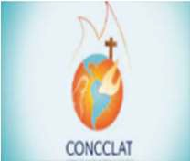
Latin American Catholic Charismatic Council
Mr. Andrés Arango

Latin American Youth Secretary
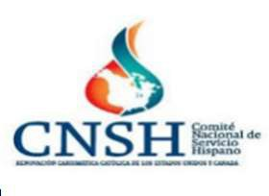
Ms. Katherine Leiva

NATIONAL
RCC USA & Canada Service Committee
Mrs. Kathia Arango
National Youth Secretary
Mr. Marcos Garcia

REGIONAL 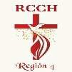
Regional Representative
Mr. José J. Soto
Regional Youth Representative
Mr. Oscar Serrano

DIOCESAN
Coordinator
Mr. Maynor Ramirez
Diocesan Youth Secretary
Mr. Adrian Gonzalez

Diocesan Team
Composed of the Coordinators and Sub Coord. of the Prayer Groups and the Diocesan Council. They meet monthly on the second Saturday of each month at Jesus the Worker Church in Fort Myers. The meeting is from 8:30am to 12:30pm. This meeting is attended by the Prayer Group Coordinator and his Helm Team. At these meetings, Lauds are prayed, events are planned, training and guidance are offered, all under the supervision of spiritual advisors.

Diocesan Ministries

Evangelization
The Charismatic Renewal as a means of Evangelization offers Life in the Holy Spirit Seminars and Growth in the Holy Spirit Seminars. We offer these Seminars in parishes through Prayer Groups. We have a Diocesan Team of Evangelizers.

Formation

We have a Diocesan Formation plan for RCCH leaders. Spiritual formation is given to all group leaders on a monthly basis at our meeting.

Intercession

We have a Diocesan Intercession Ministry, which meets every Wednesday to pray for the intentions and needs of every prayer group in our diocese. The Coordinator of the Ministry belongs to the RCCH Regional Intercession Ministry.

Juvenile

The Diocesan Youth Secretariat is made up of young people from the different prayer groups in our Diocese. They are available to participate in the seminars we offer, and in that way can cater to any young people who attend our Evangelism events. They are also available to participate in any retreat at the parish or diocesan level.

