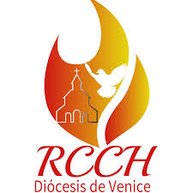

2026 ACTIVITIES CALENDAR

HISPANIC CATHOLIC CHARISMATIC RENEWAL

1.CATHOLIC CHARISMATIC CONGRESS
(November 14, 2026)
The whole community participates.

2. SERVERS MEETING
(April 11, 2026)
All the prayer groups servers participate.

3. LEADERS MEETING
(July 2026)
For coordinators or the Helm Team

4. VIGIL OF PENTECOST
(Saturday before Pentecost)
Everyone participates.

5. HOLY ROSARY
(Every Wednesday at 7pm)
(Virtual meeting)
All the diocese's prayer groups.

6. DIOCESAN MONTHLY MEETING
(2nd Saturday of each month)
Except for the month of July.

7. LIFE IN THE SPIRIT SEMINARS
(Annual Event)

