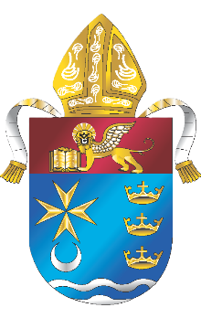
The New Church of the Ascension
Fort Myers Beach

Leave a legacy! Name a part of the new Church of the Ascension in Fort Myers Beach for your family, or in loving memory of a friend or family member.
Browse some examples of naming opportunities below or, if you have an idea of your own, let’s talk about it!
To discuss naming opportunities at the new Church of the Ascension in Fort Myers Beach, please email us at: newascension@dioceseofvenice.org

Naming Opportunities may include, but are not limited to:
- Tabernacle
- Altar
- Baptismal Font
- Religious Statues
- Pews
- Memorial Garden Bench
- Windows
- Stained glass windows
- Liturgical Items
- Sacred Art

