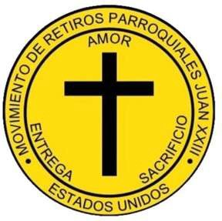

JOHN XXIII PARISH RETREAT MOVEMENT – DIOCESE OF VENICE, FL

CALENDAR OF ACTIVITIES FOR THE YEAR 2026

January 2026
10 hours of Prayer: Saturday 10.

February 2026
Regular area meeting.
Follow-up Retreat: Saturday 7.
Gentlemen's Retreat #46: Friday 20 to Sunday 22.
Start of Training Classes: Saturday 28th.

March 2026
Regular area meeting.
Training Classes: Saturday 28th.

April 2026
Ladies Retreat #47: Friday 24th to Sunday 26th.

May 2026
Regular area meeting.
Training Classes: Saturday 23rd.

June 2026
Regular area meeting.
Training Classes: Saturday 27th.

July 2026
Regular area meeting.
Training Classes: Saturday 25th.

September 2026
Gentlemen's Retreat #48: Friday 11th to Sunday 13th.

October 2026
Triduum of Prayer: Friday 9 to Sunday 11 at Campo San José, Lake Placid.
Ladies Retreat #49: Friday 23rd to Sunday 25th

